It is my hope that a recent online “fad” has come and gone faster than I have been able to contact you.  Have you heard of the “Momo Challenge”?  Think of it as an urban legend, quite scary and disturbing, and having very little truth to it.  I found this article in Rolling Stone magazine “What is Momo Challenge? And Why are Parents Freaking out” to be quite informative about the history of MoMo Challenge and the fears it is inducing.

<https://www.rollingstone.com/culture/culture-news/what-is-momo-challenge-800470/>

Momo Challenge has been around for a while - in short the challenge includes a scary image of a character named Momo that derived from Japan and has birdlike features.  Momo may then go on give instruction to do harmful things, including self harm or suicide.  Like any urban legend or the game of telephone, how the story/challenge is interpreted or shared is a little different depending on where you are.

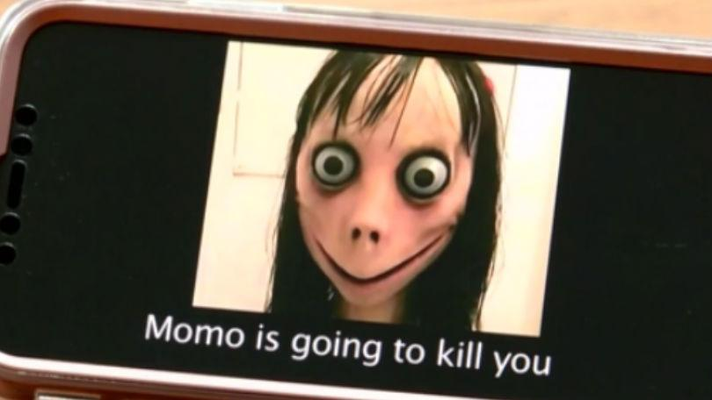

So now you might be wondering, "What does the MoMo Challenge looks like at Garretson Middle School and High School? How does this affect my student?"  I heard our students talking about it for the first time Thursday and Friday this week.  One of the students that I talked with described Momo as a doll that will haunt them and tell them to do scary things like hurting or killing themselves.  Students were sharing an image of MoMo and the story.  Most  students are laughing at the ridiculousness, but some are our youth are probably curious and looking to the internet for answers, and some our of our students scared.  I framed it to the student I talked with that Momo is like a scary movie. It is not real and it cannot hurt you.  I was pleased when the student found me the next morning and told me she got a good night sleep!  This student said when she thought of Momo, she thought of our conversation and knew Momo wasn’t real. Please have similar conversations with your child.  We don’t want to feed into the hysteria by over reacting, but we do want our children to be informed and have facts for all of the tough stuff in life!

There is good reason to believe that this latest online “challenge” is nothing more than an internet hoax. However, the ensuing coverage, spread, and discussion of the “challenge” via social media may still cause anxiety and stress to students.  My favorite line in the Rolling Stone article is at the end, “Ultimately, the internet is a pretty scary place for kids, and parents have a lot to freak out about as is. There’s probably no need to add a shrieking bird lady sculpture from Japan to the list.”

Let this latest fad be a reminder for us adults to be in tune to what our students are talking about and what is out there on the internet. To help you best navigate the “scary” world of the internet and your children, we encourage to seek resources and be constantly in tune to what your children are watching and seeing.  Properly monitored, the internet and social media can a tool for so much good too – research, positive social connections, and fun!

Please remember, you have control over their electronic device(s).  If your student has a social media account, please consider age appropriateness and exposure from older siblings or friends.  We encourage families to take this as an opportunity to have intentional conversations about what they encounter online. Really stop to listen to what your child has to say.  These discussions could include:

·Reminding children to never contact strangers online, on any platform;

·Encouraging children to share any worries or concerns with you;

·Ensuring children understand the importance of not giving personal information to anyone they do not know;

·**Telling children no-one has the right to make them do anything they do not want to do;**

·Setting privacy systems on devices with your child as a way to have the conversation about safety.

It is also important for parents to know what children can access online. Families may want to consider:

·Setting privacy settings for all social media and gaming applications;

·Keeping video games and YouTube watching in shared family spaces;

·Setting up video game restrictions to friends only; Many children feel it is okay if they are playing electronic games to play the games with people they do not know.  Please know, grooming can occur in which an on-line person attempts to befriend your child.  All can feel very innocent for children when safety can be a hidden concern.

·Setting up “restricted” mode on YouTube for your child’s account so inappropriate content is not available to them.

* Also be aware there are applications that encourage dishonesty, for example Instagram allows duplicate Finstagram accounts.

Please use this time to become more aware of what your kids are doing online.  Allow this negatively to turn into a chance to talk to your kids.  The safety of our student body is our utmost priority.  There are smart phone Apps to monitor your child’s phone:  Net Nanny, Secure Teen, Teen Safe, Mobicip (parental control cloudware).  With these apps you can block types of websites, be alerted to keyword searches (i.e. suicide), monitor call logs, text messages, pinpoint GPS, and use Apple to restrict phone usage.  Go to the following internet site to find out your cell phone provider’s available filter programs:

•         [http://www.growingwireless.com...](http://www.growingwireless.com/learn-engage/parental-control-tools/parental-controls-features-and-resources)

Feel free to contact me if you have any specific questions or concerns.  I appreciate your time!  Together we can get our students through the toughest of times and put the focus where it belongs - on all the potential they have for the world and that the world has for them!  Even the potentially online world.

Michelle Pliska, LPC, QMHP

School Counselor Grades 6-12

Board Certified Counselor

Garretson School District 49-4  
505 2nd St., PO Box C

Garretson, SD 57030

Phone: 605-594-3451 Ext. 115

Michelle.Pliska@K12.SD.US